

Clinical Guideline for:
The provision of sub-Tenon anaesthesia and conscious sedation for ophthalmic surgery
by Anaesthesia Associates

Summary
These guidelines should be read in conjunction with the Royal College of Anaesthetists / Royal College of Ophthalmologists document, “Local anaesthesia for ophthalmic surgery” 2012, and the Royal College of Anaesthetists and “Guidelines for the Provision of Ophthalmic Anaesthesia Services 2022”

Key Points
The essential elements of this guideline are:
- Responsibilities
- Scope of Practice
- Technique
- Relative / Absolute Contraindications

Publication Details
Author of Clinical Guideline | Steph Hayes – Anaesthesia Associate  Dr Paul Thomas – Consultant Anaesthetist  Dr James Lloyd – Consultant Anaesthetist  Written in consultation Michael Smith and James Benzimra, Consultant Ophthalmologists
Department responsible for Clinical Guideline | Anaesthetics, Surgical Services Division
Contact details | Ext. 2475 / 2474: stephanie.hayes@nhs.net
Version number | 3.0
Replaces version number | 2.0
Date written | July 2016, revised 2019 and 2022
Approving body and date approved | Anaesthetics/Theatres Governance Group: 13/09/22  Ophthalmology Governance Group: 09/09/22
Review date (3-6 months prior to expiry date) | 13/03/25
Expiry date | 12/09/25
Date document becomes live | 16/09/22

Contents

1. Responsibilities 3
2. Scope of Practice 3
3. Technique 3
4. Relative / Absolute Contraindications 5
5. Sedation 5
6. Requirements for the practice of sedation 7
7. Monitoring Compliance with this Guideline 6
8. References 7
9. Associated Clinical Guidelines / Policies 8

1.0 RESPONSIBILITIES

1.1 Anaesthesia Associates (AAs) have completed a 27 month anaesthetic training programme and achieved a Post Graduate Diploma in Anaesthesia. They are required to be entered on the voluntary register held by the Royal College of Anaesthetists. They have a robust annual CPD process.
1.2 AAs have been providing local anaesthetic eye blocks for patients undergoing cataract surgery since 2006. To date, there have been no reported clinical complications within the provision of their practice.

1.3 The Anaesthesia Associate is responsible for their own actions either under the direct/indirect supervision of an experienced anaesthetist and/or the direct supervision of the ophthalmic surgeon with whom they are working at the time.

1.4 The safety and best interest of the patient is of primary importance at all times, and where any doubt exists, the practitioner should call for senior assistance or advice.

1.5 It is the practitioner's responsibility to ensure that revalidation is undertaken annually.

2.0 SCOPE OF PRACTICE

2.1 Sub-Tenon anaesthesia may be administered by the Anaesthesia Associate for a wide variety of ophthalmic surgical procedures.

2.2 Each patient on a proposed operating list should be discussed in turn at the Team Brief and an anaesthetic management plan agreed as to who is to perform the block prior to starting the list.

3.0 TECHNIQUE

3.1 The patient’s medical history should be read and their medications, fitness for local anaesthesia and consent to the procedure documented. Particular attention should be paid to the patient’s ability to lie flat and still for the anticipated duration of surgery. Attention should also be paid to the patient’s anxiety levels and any cardiorespiratory comorbidity which may affect their ability to cooperate with a local anaesthetic technique.

3.2 A full explanation of the anaesthetic procedure should be given and verbal consent gained. The correct side for surgery should be checked against current consent form matched to the patient identity bracelet and verbally confirmed with the patient adhering to Safe Surgery and Interventional Procedures Policy.

3.3 The patient should be made comfortable on a trolley and have heart rate and oxygen saturation monitored throughout block insertion and surgery.

3.4 The eye should be instilled with topical local anaesthetic drops (proxymetacaine 0.5% w/v) before the eye and surrounding skin is prepared with a solution of Povidone-iodine 5% w/v (or chlorhexidine 0.02% in the case of iodine allergy).

3.5 A trolley should be prepared with a sterile drape and sterile sub-Tenon set (containing a phaco-speculum, Westcott scissors and Moorfields’ forceps), 5ml syringe, filter needle, sub-Tenon cannula (BD Visitec 1.1x25mm or Eagle Triport needle), local anaesthetic drops (proxymetacaine 0.5%) and swab using aseptic technique.

3.6 Following hand-washing the operator should wear sterile surgical gloves and draw up the local anaesthetic solution using an aseptic technique.

3.7 The phaco-speculum should be inserted carefully to avoid abrading the cornea and the patient instructed to look upward and outward. Further local anaesthetic drops should be instilled infero-medially. The conjunctiva and Tenon’s capsule should be lifted with Moorfields’ forceps at a point 5mm from the limbus in the infero-nasal quadrant (fig 1) and a small incision made with Westcott scissors.

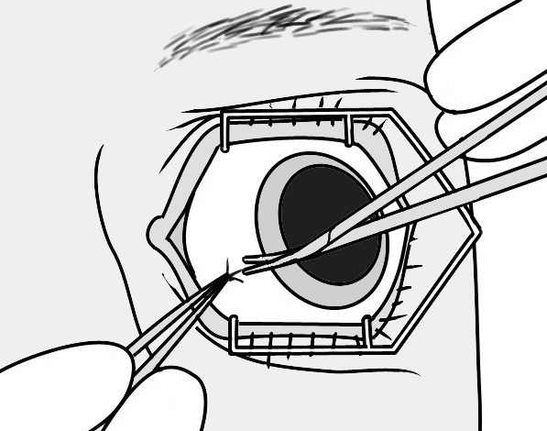
Figure 1. Point of incision

3.8 A curved, blunt ended needle should be inserted underneath Tenon’s capsule using blunt dissection to follow the curve of the globe. (figs 2-3)

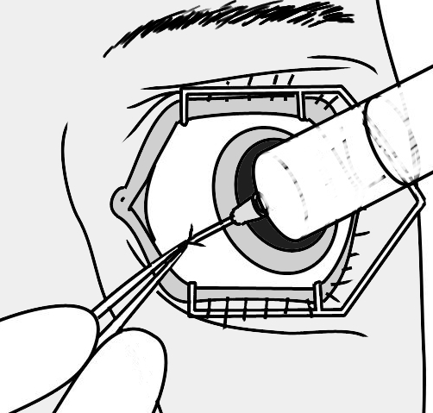  Figure 2. Insertion of cannula | 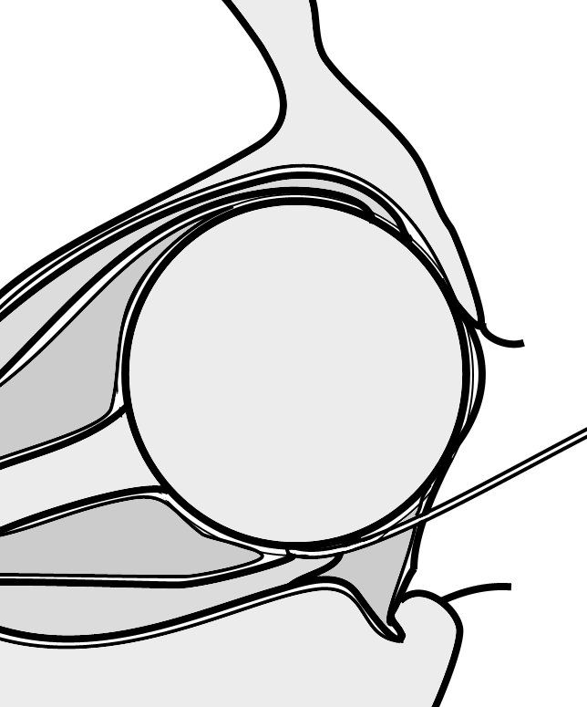  Figure 3. Cross section of eye showing cannula placement

3.9 Alternatively, an incisionless ‘lift and pop’ technique may be employed using the same anatomical landmarks at the discretion of the AA.

3.10 The patient may be instructed to look straight ahead at this point and an appropriate combination of lidocaine/levobupivacaine/hyalase up to a total volume of 5mls should be gently injected. The speculum should be carefully removed and the patient instructed to close their eye. Gentle massaging pressure should be applied to facilitate the retrograde spread of local anaesthetic solution.

3.11 If conjunctival dissection proves difficult or if excessive force is required for needle insertion, the procedure should be abandoned and advice sought from the operating surgeon.
  - Consider the use of topical adrenaline 1:1000 to reduce the incidence of haematoma.

- RELATIVE / ABSOLUTE CONTRAINDICATIONS

4.1 Anticoagulation
If a patient’s coagulation profile is markedly outside their own target therapeutic range or >3.5 postponing surgery to allow a review of anticoagulant treatment regime is recommended.
‘For ambulatory cataract surgery it is not advisable to stop the anticoagulants (warfarin) and antiplatelet drugs (aspirin, Clopidogrel, dypyradamole) as the risk of stopping these drugs may outweigh the risk of peri-operative haemorrhage…. Currently there is insufficient evidence to make anaesthesia-specific recommendations regarding continuation or cessation of these drugs. Each patient and procedure should be treated on its own merits with multi-disciplinary input as required.’ (Extract from joint RCoA and RCO guidelines).
4.2 Axial length
Whilst of importance when performing peri/retro bulbar sharp needle techniques, there is no clinical reference made in any of the national guidelines to the relationship of axial length and risk of globe perforation when performing a sub-Tenon’s block.
4.3 Blood pressure
Systolic BP > 200 consider postponing or other management plan after multidisciplinary discussion.
If patient known to be hypertensive, particular care should be taken to avoid traumatising small subconjunctival vessels when performing block.
Discuss proposed management of individual cases at Team Brief before the start of the list.
‘Uncontrolled hypertension may increase the risks of systemic and ophthalmic complications. However there is insufficient evidence to support a specific value above which surgery should be deferred.’ (Extract from joint RCoA and RCO guidelines).
4.4 Blood sugar
‘At present there is insufficient evidence to recommend cancelling the surgery above a certain high level of blood sugar and clinical judgement should prevail.’ (Extract from joint RCoA and RCO guidelines).
It would seem reasonable to proceed with surgery providing the patient does not have an altered state of consciousness secondary to hypo/hyperglycaemia.
Discuss proposed management of individual cases at Team Brief before the start of the list.
4.5 Medical considerations
Do not perform block in the case of:
- Severe physiological derangement such as fast AF >120, angina at rest or other cardio/respiratory comorbidities likely to make cooperation with anaesthesia and surgery difficult or unsafe.
- Known allergy to local anaesthetics or hyaluronidase
- Viral or bacterial infection of the eye.

4.6 Surgical considerations
Early referral to ophthalmic surgeon to perform sub-Tenon block is recommended in the following instances:
- Previous surgery affecting infero-medial quadrant
- Previous laser surgery affecting infero-medial quadrant
- Previous trabeculectomy or cryo-buckle/encirclement
- Discuss with surgeon in the case of all other previous surgery to the eye.
4.7 Patient considerations
Do not perform in the case of:
- Patient non-compliance through claustrophobia
- Patient non-compliance or potential problems related to anxiety unless sedation logistically feasible.

5.0 SEDATION AND SEDATION REQUIREMENTS
5.1 Anaesthesia Associates at the RDUH have been practising in anaesthetics for many years under the supervision of an anaesthetist. Their training includes being capable of giving full general anaesthetics from induction to recovery. This part of the guideline is intended to expand the current scope of the role to enable the AA to administer anxiolytic drugs where necessary under the direction of a surgeon. This will enable future workforce planning in expanding service capacity and skill mix within anaesthetic staffing and scheduling.
5.2 The requirement for a combined local anaesthetic and sedation technique is currently most commonly requested for ophthalmology patients undergoing cataract surgery. These patients have their surgery routinely performed as a day case procedure either on main site at Wonford or at Axminster Community Hospital.
5.3 This guideline builds upon the scope of practice of experienced AAs and has been designed to improve the patient experience for those requiring a short acting anxiolytic for their procedure.
5.4 Background
5.4.1 Currently an anaesthetist is requested to be present in the theatre suite when a patient requires sedation in addition to their local anaesthetic eye block, most commonly for cataract surgery. In this situation, the AA has continued to perform the local anaesthetic eye block whilst administering conscious sedation with an anaesthetist providing supervision from another theatre. The input from the anaesthetist has been in place for the rare occasion of any adverse effects from the sedation. To date, AAs have not had any reported clinical adverse outcomes of their administered sedation practice or required any help from the nominated anaesthetist.
    - The development of the AA role of taking responsibility and accountability for administering sedation will advance their scope of practice and be of significant value to anaesthetic scheduling and service delivery. It also allows patients to change their mind with regard to sedation on the day of surgery, a situation which currently leads to the case being cancelled and rescheduled.

6.0 REQUIREMENTS FOR THE PRACTICE OF CONSCIOUS SEDATION
6.1 Pre-operative preparation for surgery
- Standard preparation for surgery will be followed using local and national guidance
- Informed consent will be acquired from the patient and expectations of conscious sedation providing anxiolysis and not sleep will be discussed
- The patients’ medical history, allergies and previous anaesthetic history will be obtained and documented
- In line with Guidelines for the Provision of Ophthalmic Anaesthesia Services, RCOA 2020, patients do not need to be starved when sedative drugs are used in low doses to produce simple anxiolysis
- If there are any doubts or concerns for the patient not being appropriate for sedation, current practice of escalation to the on-call consultant anaesthetist will be followed.

6.2 Patient Monitoring
- Standard monitoring of the patient will be required throughout the sedation process, following local and national guidance
- Anaesthetic equipment will be checked and ready to use, including emergency equipment and resuscitation drugs must be available for immediate use following the event of an anaesthetic emergency, as in line with local and national guidance
- Oxygen will be administered to maintain oxygen saturations in the patient’s normal range throughout sedation administration
- Patients will be recovered post sedation by trained staff in line with standard recovery protocol and discharged to the ward when all recovery criteria are met.
6.3 Documentation
All standards of care and monitoring of vital signs will be documented using the Trusts electronic patient record system. The Trust’s Safe Surgery and Interventional Procedures Policy will be followed and documented.
6.4 Drugs
Sedative agents will be titrated to effect. Following current practice, all patient specific drugs will be prescribed by a doctor in line with Trust ordering and drug administration policies.

7.0 MONITORING COMPLIANCE WITH THIS GUIDELINE
7.1 This clinical guideline will be monitored through the Trust governance approval and review process. AAs follow a robust CPD process. As such AA knowledge and practice will be reviewed annually as part of the professional development review process, with audits reported to the Anaesthetics/Theatres Governance Group.

8.0 REFERENCES

Royal College of Anaesthetists and the Royal College of Ophthalmologists (2012). Local anaesthesia for ophthalmic surgery (February 2012). Available at:
https://www.rcoa.ac.uk/document-store/local-anaesthesia-ophthalmic-surgery
[Accessed 19-07-2019]
Royal College of Anaesthetists Guidelines for the Provision of Ophthalmic Anaesthesia Services 2022. Available at: https://www.rcoa.ac.uk/gpas/chapter-13
Royal College of Anaesthetists (2019): Guidelines for the Provision of Ophthalmic Anaesthesia Services 2019. Available at:
https://www.rcoa.ac.uk/document-store/guidelines-the-provision-of-ophthalmic-anaesthesia-services-2019

9.0 ASSOCIATED CLINICAL GUIDELINES AND POLICIES
9.1 Royal Devon and Exeter Foundation Trust policies/guidelines:
- Cardiopulmonary Resuscitation (CPR) Policy
- Infection Prevention and Control Policy
- Safe Surgery and Intervention Procedures Policy
- Consent for Examination or Treatment Policy
9.2 National policy and Guidelines
- AAGBI Quick Reference Handbook for Anaesthetic Emergencies
- AABBI Full Guideline for the Treatment of Anaphylaxis
Association of Anaesthetists of Great Britain and Ireland (AAGBI)
https://anaesthetists.org/Home/Resources-publications/Guidelines
- Management of a patient with suspected anaphylaxis during anaesthesia (2009).
Available at:
https://anaesthetists.org/Portals/0/PDFs/Archive%20guidelines%20PDFs/Archived_guidelines_Suspected_anaphylaxis_reactions_4th_2009.pdf?ver=2018-08-15-112611-903 [Accessed 19-07-19]
- Recommendations for standards of monitoring during Anaesthesia and Recovery (2015). Available at:
https://anaesthetists.org/Home/Resources-publications/Guidelines/Standards-of-monitoring-during-anaesthesia-and-recovery
[Accessed 19-07-19]
Res HYPERLINK "http://www.resus.org.uk/"uscitation Council Guidelines
https://www.resus.org.uk/resuscitation-guidelines/
- Adult Bradycardia HYPERLINK "https://www.resus.org.uk/pages/bradalgo.pdf"Algorithm HYPERLINK "https://www.resus.org.uk/pages/bradalgo.pdf"(201 HYPERLINK "https://www.resus.org.uk/pages/bradalgo.pdf"5 HYPERLINK "https://www.resus.org.uk/pages/bradalgo.pdf"). Available at:
https://www.resus.org.uk/EasySiteWeb/GatewayLink.aspx?alId=6475
[Accessed 19-07-19]
- Adult Basic Life Support (201 HYPERLINK "https://www.resus.org.uk/pages/bls.pdf"5 HYPERLINK "https://www.resus.org.uk/pages/bls.pdf"). Available at:
https://www.resus.org.uk/resuscitation-guidelines/adult-basic-life-support-and-automated-external-defibrillation/
[Accessed 19-07-19]
- Adult Advanced Life Support (201 HYPERLINK "https://www.resus.org.uk/pages/als.pdf"5 HYPERLINK "https://www.resus.org.uk/pages/als.pdf"). Available at:
- Guideline
https://www.resus.org.uk/resuscitation-guidelines/adult-basic-life-support-and-automated-external-defibrillation/
- Algorithm
https://www.resus.org.uk/EasySiteWeb/GatewayLink.aspx?alId=6442
[Accessed 19-07-19]
- Adult Tachycardia HYPERLINK "http://www.resus.org.uk/pages/tachalgo.pdf"Algorithm HYPERLINK "http://www.resus.org.uk/pages/tachalgo.pdf"(201 HYPERLINK "http://www.resus.org.uk/pages/tachalgo.pdf"5 HYPERLINK "http://www.resus.org.uk/pages/tachalgo.pdf"). Available at:
https://www.resus.org.uk/EasySiteWeb/GatewayLink.aspx?alId=6477
[Accessed 19-07-2019]

